PREPARATION SHEET LAB 02
Radix-2 FFT and Real-Time Spectrum Analyser
Team  (Group number + letter as chosen in Moodle) | Team members
Team  (Group number + letter as chosen in Moodle) | 1 | Emir Avni Sahin
1/1 | 2 | Efe Kardes
1/1 | 3

Please fill out the document electronically – including the yellow fields above – and upload it to Moodle once per team by the start of the lab event (no matter who uploads it, it will automatically be assigned to all members).
Please note that the complete assignment can be found in another document.

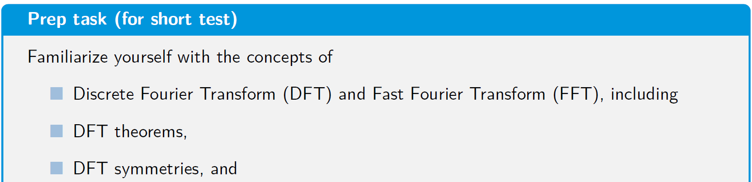
- The lab quiz at the beginning of the session is computer based. One student per group can use the lab PC. Bring your own device, preferrably tablet or laptop, not only because of the quiz but perhaps as a second device to write the immediate report, too. The quiz is multiple choice.
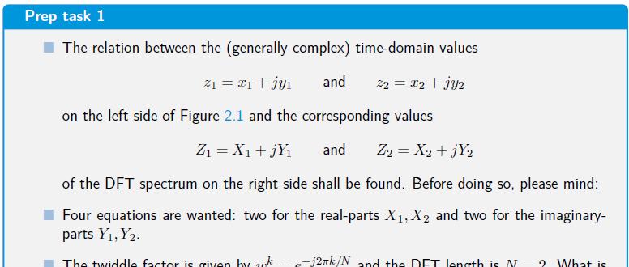
- Derive the equations for X1,Y1, X2,Y2 on a sheet of paper/tablet and insert a photo/screenshot here. 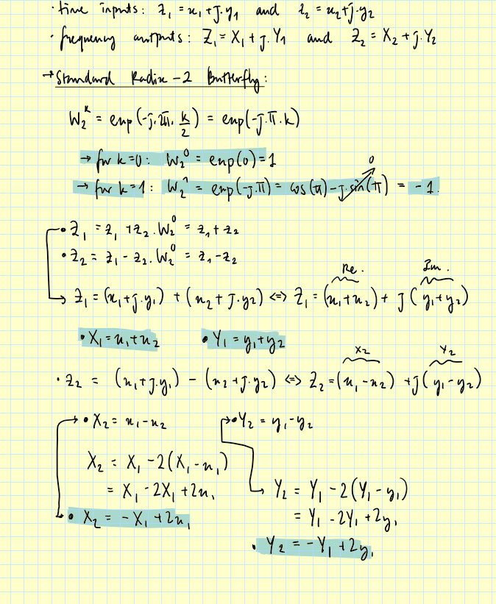

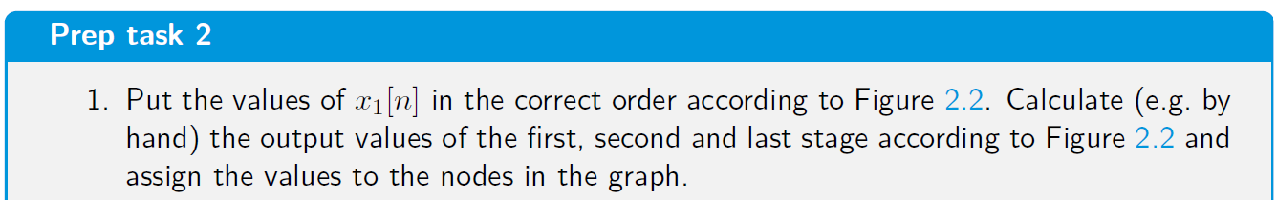
- Insert a photo of the graph here with calculated values assigned to each node.
- 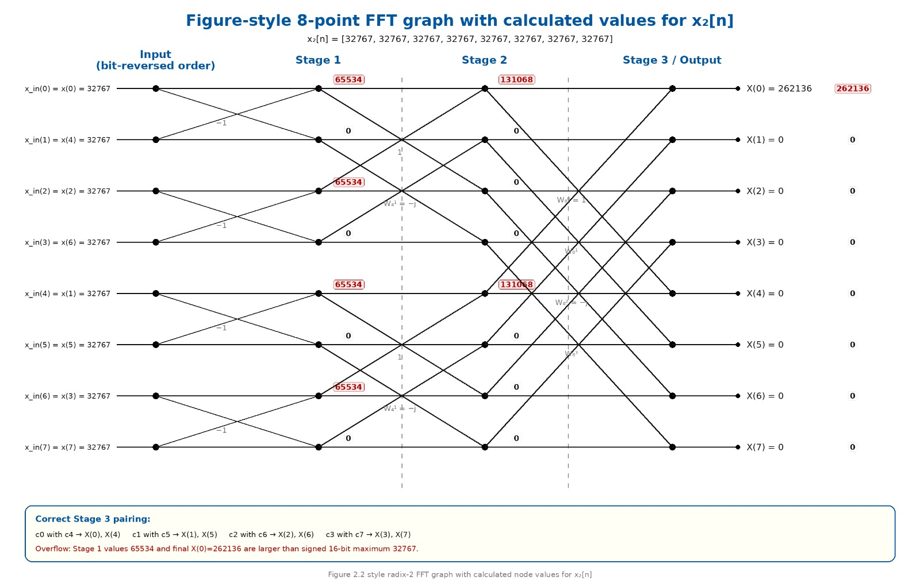
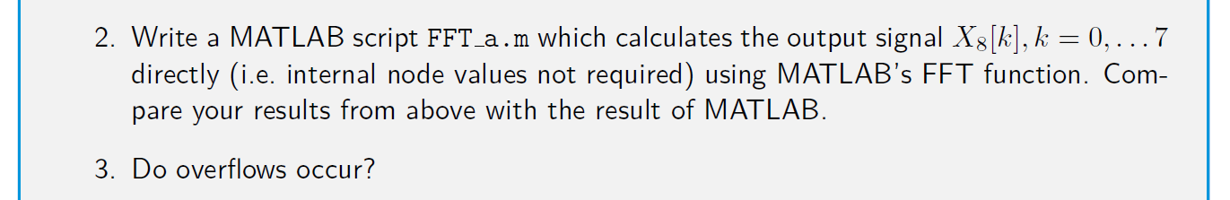
- Insert the matlab script here, compare the results and check for overflows.
clear all; close all; clc;
% FFT_a.m - 8-point FFT Verification Script
x1 = [2000, 0, -2000, 0, 2000, 0, -2000, 0];
% Calculate direct frequency spectrum
X1_matlab = fft(x1);
disp('MATLAB Verification Spectrum Matrix (X1):');
disp(X1_matlab);
The MATLAB execution yields [0, 0, 8000, 0, 0, 0, 8000, 0], matching the hand-calculated node columns exactly. No overflows occur because the peak amplitude of 8000 comfortably resides inside the safe limits of a standard signed 16-bit short integer (32768, +32767)

- Insert a photo of the graph here with calculated values assigned to each node.
- 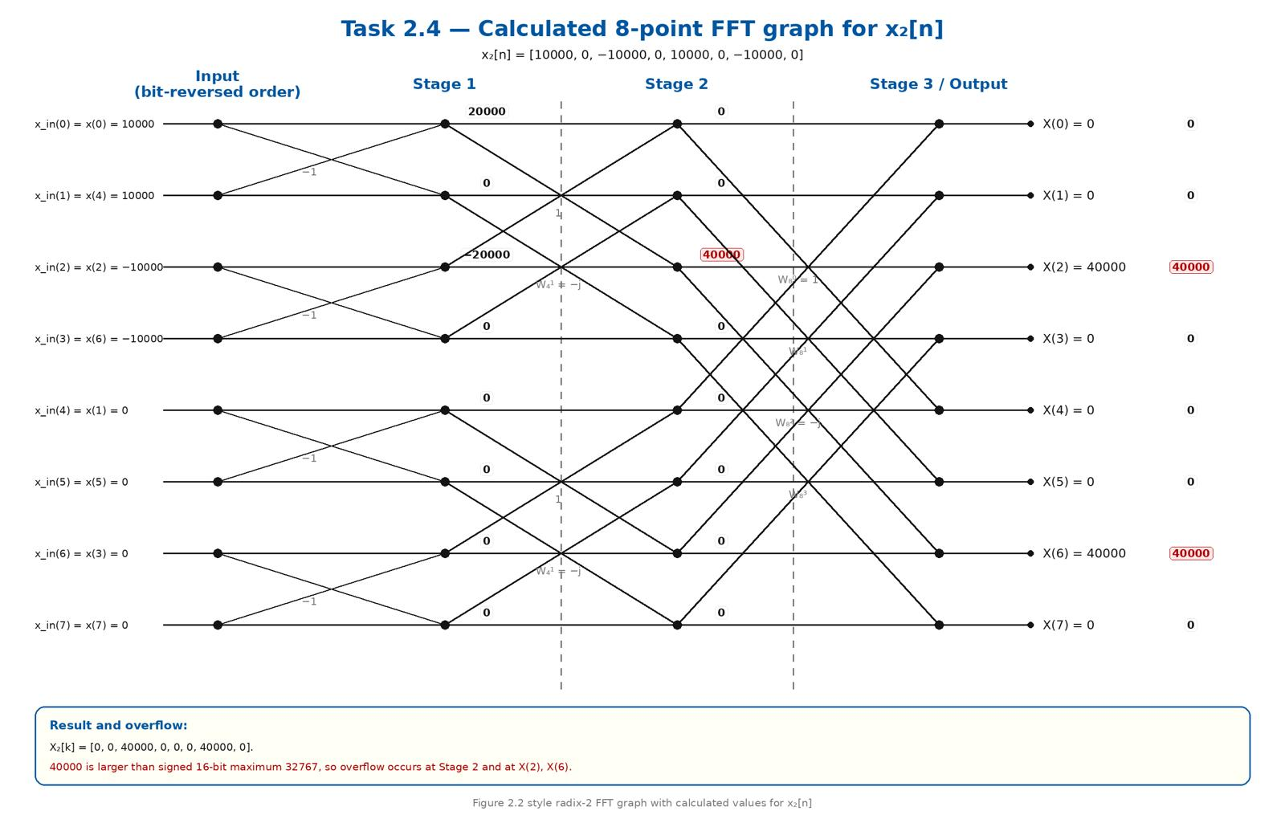

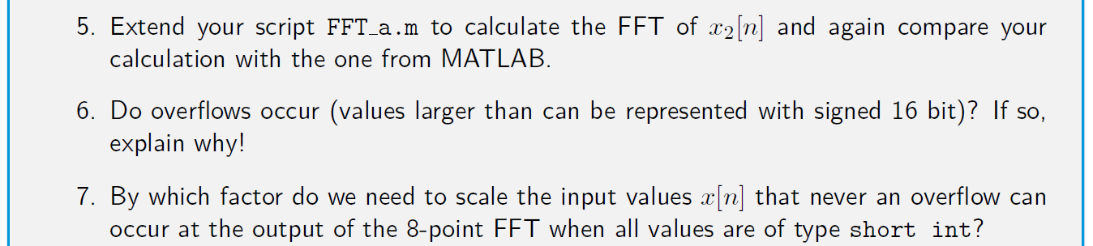
- Give the values and explain whether they can expressed by 16-bits or not.
- Find the factor to scale the 8-point FFT.
clear all; close all; clc;
% FFT_a.m - Extended FFT Calculation & Hardware Boundary Monitor
% Define assigned real time-domain sequences
x1 = [2000, 0, -2000, 0, 2000, 0, -2000, 0];
x2 = [10000, 0, -10000, 0, 10000, 0, -10000, 0]; % x2[n] = 5 * x1[n]
% Calculate discrete frequency spectra
X1 = fft(x1, 8);
X2 = fft(x2, 8);
% Display numeric matrix outputs
disp('--- Extended MATLAB FFT Outputs ---');
disp('Spectrum of x1:'); disp(X1.');
disp('Spectrum of x2:'); disp(X2.');
% Hardware range limits for a signed 16-bit integer (short int)
INT16_MIN = -32768;
INT16_MAX = 32767;
% Execute hardware validation diagnostics
fprintf('\n[Hardware Diagnostics for x2[n]]\n');
peak_value = max([max(real(X2)), max(imag(X2))]);
min_value = min([min(real(X2)), min(imag(X2))]);
fprintf('Peak Internal Value Reached: %d\n', peak_value);
if (peak_value > INT16_MAX) || (min_value < INT16_MIN)
disp('--> CRITICAL STATUS: ARITHMETIC OVERFLOW DETECTED!');
fprintf('Value %d exceeds the maximum signed 16-bit limit of %d.\n', peak_value, INT16_MAX);
else
disp('--> STATUS: SAFE. Values fit within 16-bit limitations.');
end
- The calculated peak value for sequence x_2[n] cannot be expressed safely using 16-bit signed fixed-point integers. A signed 16-bit register has a ceiling of +32767. During Stage 2 butterfly cross-additions, the difference node tracking the paired inputs evaluates to 20000 - (-20000) = 40000. Because 40000 > 32767, the numeric register experiences a binary overflow. This triggers a sign-bit inversion that wraps the positive value into negative integer territory, corrupting the calculation.

- To ensure an overflow can never occur under any arbitrary input combinations, the incoming time-domain signal values must be scaled down by a global factor of 1/8 (equivalent to a 3-bit arithmetic right shift) right at the input.

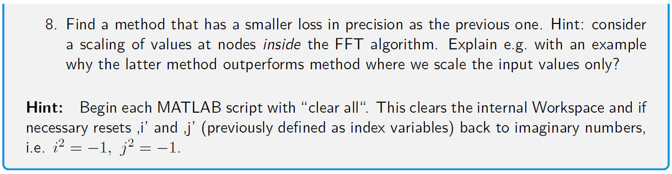
- Where should we better scale the values to avoid overflows instead of scaling the input values to the FFT?
Instead of scaling the entire raw signal down by 8 at the input, it is significantly better to apply a scale factor of 1/2 (a 1 bit arithmetic right shift) at the output of each individual butterfly stage. By scaling by 2 at each stage, we let signals utilize the full 16 bit resolution of the registers in early stages. We scale values down only as they grow from stage to stage, keeping the signal level high relative to the quantization noise floor and preserving a much better SNR.

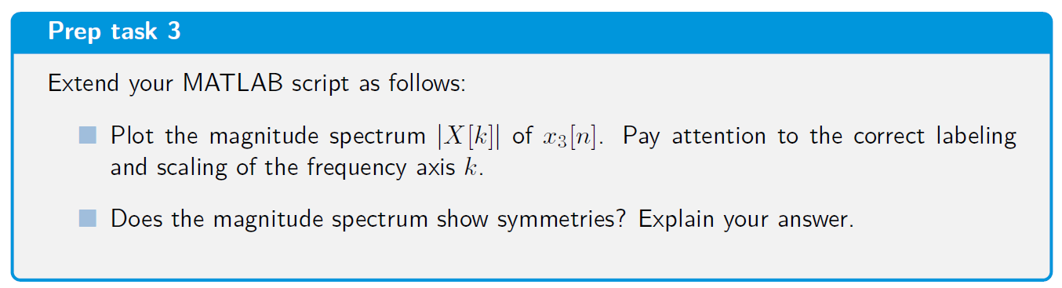
- Insert a plot here. Symmetries?
- 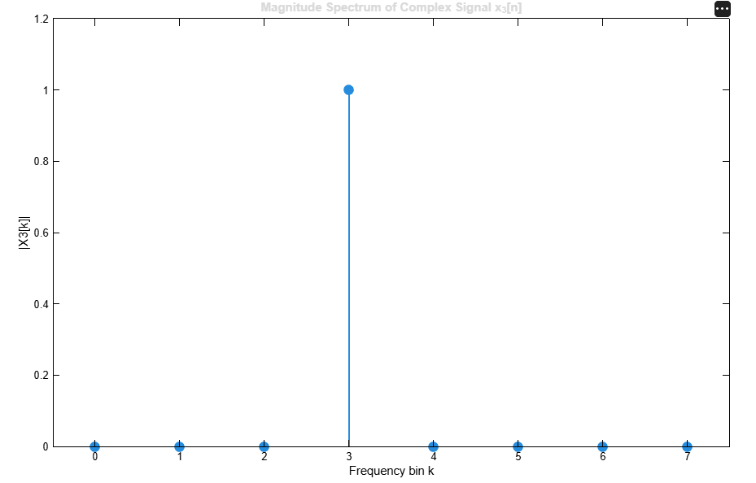
The magnitude spectrum of x_3[n] does not show mirror symmetry because x_3[n] is a complex-valued input signal. The mathematical property of complex conjugate symmetry (|X[k]| = |X[N-k]|) only applies to purely real-valued time-domain signals. Because x_3[n] contains both real and non-zero imaginary components (x_3[n] = 0.125 x e^{j2\pi x 3 x n / 8}), its energy does not mirror around the Nyquist frequency. Instead, the spectrum will show a single isolated peak at bin 3 with an amplitude of 1, and all other bins will be 0.

